 **Mount Lawley Senior High School**

**Year 8 Biological Sciences**

***End of Term Test 201******9***

**Section 1: Multiple Choice Answers – 1 mark each**

*Read all answers and choose the* ***BEST*** *one.*

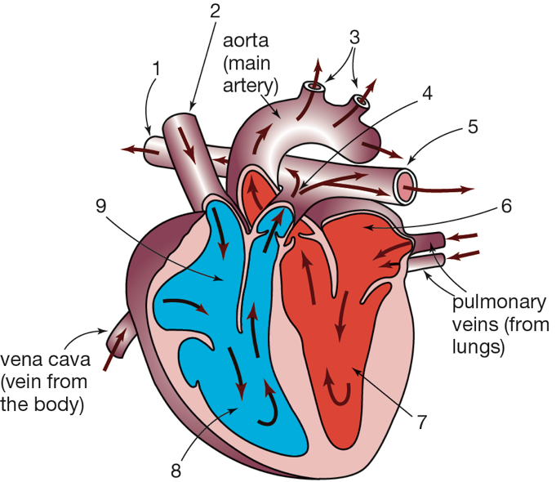1. Use the information in this diagram of the human heart to identify the correct  
 statement from the list below.

1. Blood travels to the lungs from 3 and returns into 9.
2. Blood travels to the body from 5 and returns into 6.
3. Blood travels to both lungs from 5 and returns to the heart through 2.
4. Blood travels to the body from 3 and returns to the heart through 2.

2. Which statement about asexual reproduction is correct?

1. The offspring are not identical to the parents.
2. It only happens in plants.
3. It needs just one parent.
4. It only happens in animals

3. Which of the following organisms does NOT reproduce sexually?

1. Starfish
2. Mammals
3. Birds
4. Sunflower

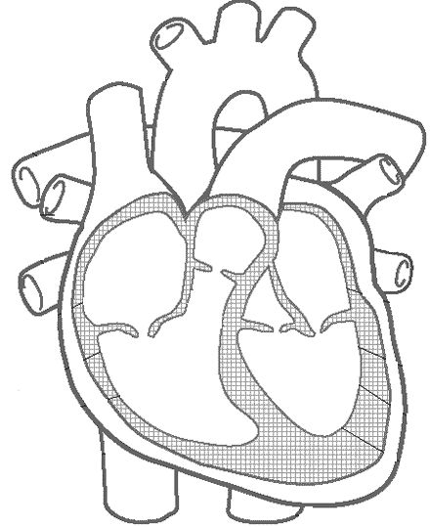4. Choose the answer that correctly labels the heart diagram **from A🡪D**

1. Right Ventricle, Right Atrium, Left Ventricle, Left Atrium
2. Left Atrium, Left Ventricle, Right Atrium, Right Ventricle
3. Right Atrium, Right Ventricle, Left Atrium, Left Ventricle

A

C

1. Left Ventricle, Left Atrium, Right Ventricle, Right Atrium

D

B

5. What are capillaries?

1. The smallest blood vessels of the circulatory system.
2. The medical name for heart muscle cells.
3. Small lumps of fatty tissue that can clog blood vessels.
4. Cells that guard against infection

6. The circulatory system is composed of:

1. The heart, blood, and blood vessels.
2. The heart, the brain, and the lungs.
3. The lungs, the blood, and the blood vessels.
4. The brain, the heart, and the blood vessels.

7. What is the main function of the respiratory system?

1. To break food down
2. Supply the blood with oxygen
3. Circulate the blood
4. Fight infectious diseases

8. Which part of the body is NOT used for the respiratory system to work?

1. Mouth
2. Nose
3. Small intestine
4. Diaphragm

9. What is your heart made of?

1. Skin
2. Tissue
3. Muscle
4. Carbon

10. From the following list predict which would show the greatest differences in the

offspring:

1. Aphids produced by parthenogenesis from one parent
2. Potato plants grown from one parent plant
3. Seedlings from the seeds of one flower
4. Moss plants grown from one spore case

11. Red blood cells transport ______.

1. Oxygen.
2. Carbon dioxide.
3. Nitrogen.
4. Hydrogen.

12. A general name for a sex cell (egg or sperm) is a:

1. Ovule
2. Zygote
3. Gamete
4. Embryo

13. Which of the following reproduce sexually?

1. Humans only
2. Humans and animals
3. Humans, animals and plants
4. Plants only

14. Hermaphrodites are organisms who:

1. Produce male or female sex cells
2. Reproduce asexually
3. Produce sex cells that can fertilise other sex cells
4. Have both male and female sex organs

15. Which of the following methods of reproduction produces the greatest differences  
 between offspring?

1. Budding
2. Spore formation
3. Fertilisation of gametes
4. Vegetative reproduction

16. Which of the following is NOT a function of white blood cells.

1. Guard against infection.
2. Fight parasites.
3. Attack bacteria.
4. Carry oxygen

17. The component of blood responsible for clotting is:

1. platelets
2. plasma
3. white blood cells
4. red blood cells

18. When a starfish loses an appendage, the appendage is able to make another starfish  
 by the process of:

1. Cloning
2. Spore formation
3. Fragmentation
4. Conjugation
5. 19. The key event in the life cycle of an organism that relates to the survival of the species is:
6. birth
7. fertilisation
8. growth
9. reproduction

20. Our throat divides into two separate tubes: one for the digestive system, the other for  
 the respiratory system. What prevents food from entering the lungs?

1. The pharynx
2. The tongue
3. The trachea
4. The epiglottis

21. Which one of the following describes a vein?

1. It has thin walls and carries oxygenated blood away from the heart.
2. It has thick walls with valves and carries blood under pressure.
3. It has a very thin wall with valves and carries blood under pressure.
4. It has thin walls with valves, and carries blood to the heart

22. Which blood vessel carries blood from the heart to all parts of the body?

1. Vena cava
2. Anterior cardiac vein
3. Aorta
4. Right coronary artery
5. 23. Which one of the following reproduces using spores?
6. frog
7. fungi
8. hydra
9. flowering plant

24. Which of the following statements is not true?

1. arteries - transport blood away from the heart
2. arteries - return blood from the tissues to the atria
3. capillaries - site of exchange of substances between the blood and tissue fluid
4. veins - rely on muscle contraction to assist blood movement

25. Aphids have separate male and female individuals. Aphids often reproduce by parthenogenesis, during which females produce eggs that turn into young aphids. However, this is an example of asexual reproduction. The explanation for this classification must be that:

1. asexual reproduction involves making eggs.
2. male aphids do not produce sperm.
3. the eggs were never fertilised.
4. aphids do not reproduce sexually.

26. All living things carry out the process of respiration, which provides them with the energy they require. Plants also carry out photosynthesis, a process that uses energy from light to produce stored energy in the form of glucose. These processes can be represented by equations:

Respiration: glucose + oxygen 🡪 carbon dioxide + water + energy

Photosynthesis: carbon dioxide + water  glucose + oxygen

Identify the true statement. All living things:

1. produce glucose and oxygen.
2. use carbon dioxide and water.
3. produce carbon dioxide and water.
4. require sunlight to produce energy.

27. With circulation, the heart provides your body with:

1. Oxygen
2. Nutrients
3. A way to get rid of waste
4. All of the above

28. The nose serves all the following functions except ________.

1. as a passageway for air movement
2. trigger the cough reflex
3. warming and humidifying the air
4. filtering the air

29. This graph shows that the breathing rate increases when you start exercising but that it does not necessarily continue to increase as you continue to exercise.

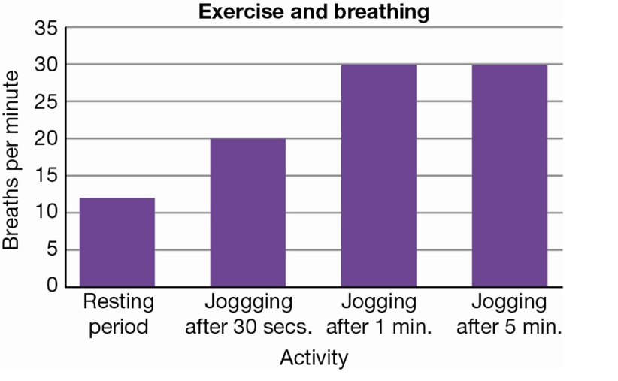

Identify the statement that *cannot* explain the data in the graph.

1. As you start to exercise, your breathing rate increases because you need more oxygen for your muscles to work.
2. Physical activity produces more carbon dioxide in your body and you have to get rid of it.
3. When you do a lot of exercise you breathe more deeply and you do not have to breathe as often.
4. When you are exercising at a constant rate your breathing rate becomes constant.

30. What is one advantage of taking cuttings from plants?

1. New, genetically identical plants can be grown quickly and cheaply.
2. All the offspring produced will be susceptible to the same diseases.
3. New varieties are produced with each cutting, depending on which plant hormone is used.
4. Fruit can be grown that will be resistant to pests

**Section 2: Short Answers 54 marks**

***The human circulatory system is referred to as a double system.***

1a. Describe the difference between the blood that is pumped to the lungs and the blood that is pumped to the rest of the body. *(Think in terms of the types of gases in the blood)*   
 (2 marks)

Blood to lungs is low in oxygen & high in carbon dioxide (Deoxygenated) (1)

Blood to body is high in oxygen and low in carbon dioxide (Oxygenated) (1)

_____________________________________________________________________________________

_____________________________________________________________________________________

b. Explainwhat is meant by a double system. (2 marks)

There are two separate circuits through which the blood flows.

Blood goes to lungs (1) Blood goes to the rest of the body (1)

Oxygenated half ( ½ ). Deoxygenated half ( ½ )

_____________________________________________________________________________________

_____________________________________________________________________________________

2a. **State** what a Clone is: (1 mark)

A genetically identical (1/2) offspring (1/2)

_____________________________________________________________________________________

b. Describe what happens in Fertilisation: (1 mark)

The sperm enters the egg/ovule

_____________________________________________________________________________________

c. **Compare** the difference between internal and external fertilisation. (2 marks)

Internal: fertilisation takes place **inside** the female’s body (1)

External: fertilisation that takes place **outside** the female’s body (1)

_____________________________________________________________________________________

__________________________________________________________________________________________________________________________________________________________________________

3a. **Label** the diagram of the flower below. (8 marks)

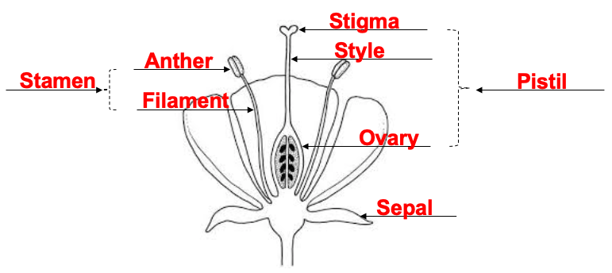

b. **Circle** the label for the female part, and **Box** the label for the male part (1 mark)

4a. **Explain** the difference between Cross pollination and Self-pollination. (2 marks)

Cross pollination – pollen comes from another flower (1)

Self –Pollination – pollen comes from the flower itself/same flower (1)

_____________________________________________________________________________________

__________________________________________________________________________________________________________________________________________________________________________

b. **List** the Methods of Pollination: (2 marks) ____________________________________________________________________________________

(1/2 mark each) Wind, Insect, Bird, Mammal

c. Look at the diagrams below. Next to each **State** what method of pollination is used and **justify** your answer. (4 marks)

**FLOWER 1 FLOWER 2**

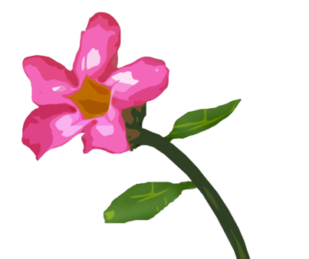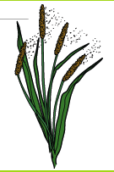

No petals

Bright pink petals

No bright colour

Long stamen & anther

Strong scent

Landing guides

**Insect (bees would get ½ mark)**

**Wind**

Method of pollination: ________________ Method of pollination: __________________

**long stamen** to catch

the wind (1/2)

Don’t need bight petals to attract insect (1/2)

**bright petals** /landing

guides so insects can see (1/2)

**Scent** to attract insects (1/2)

Reason why: _________________________ Reason why: __________________________

_____________________________________ _______________________________________

_____________________________________ _______________________________________

5. Complete the following table comparing asexual and sexual reproduction (6 marks)

|  |  |  |
| --- | --- | --- |
|  | **Asexual reproduction** | **Sexual reproduction** |
| Number of parents | 1 | 2 |
| Genetic info compared to parents | Same/identical | Different/Unique |
| Amount of offspring | Many/Large amount | Few/Small amount |
| Example of an organism that uses this Type  AND  The specific method the organism uses | Organism:  Method:  Table Below | Organism: Flowers; Fish/amphibians; Other Animals  Method:Pollination; Internal F;  External F |

6 a. **Explain** why our bodies need Oxygen. What does our body use it for? (1 mark)

**To make Energy**

____________________________________________________________________________________________

b. The **process** that changes Oxygen into Carbon Dioxide is **called** what? (1 mark)

**Cellular Respiration**

____________________________________________________________________________________________

c. **Complete** the word equation for the above process: (2 marks)

**Oxygen Glucose Energy Carbon Dioxide**

________________ + _______________ 🡪 Water + ______________ + ______________________

7 a. **Label** the following diagram: (6 marks)

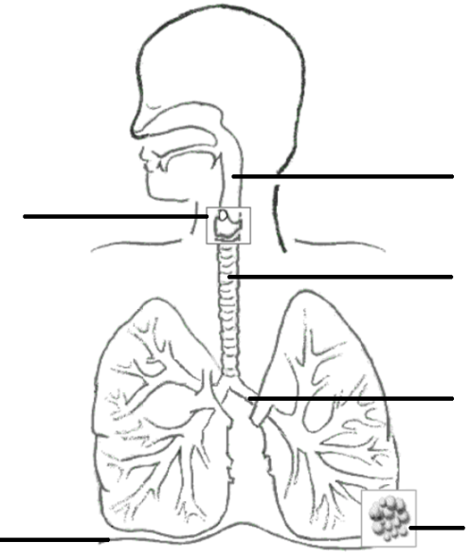

**Pharynx**

**Throat (1/2)**

**Larynx**

**Voice box (1/2)**

**Trachea**

**Windpipe (1/2)**

**Bronchus**

**Alveoli**

**Diaphragm**

**Diaphragm**

b. **Which** **muscle** is responsible for breathing? ________________________ (1 mark)

c. **Indicate** which picture below shows ‘**Inhalation’** and which picture shows **‘Exhalation’**.

(1 mark)

**Inhalation Exhalation**

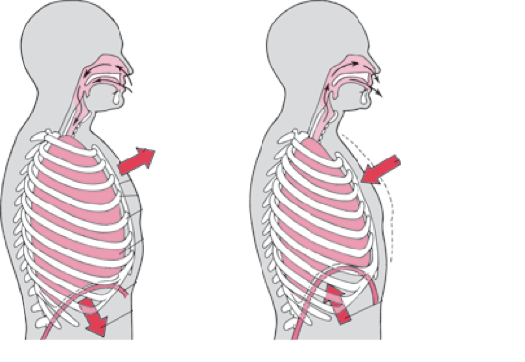 ________________ _______________

8. **Describe** the 2 features that make the Alveoli good at gas exchange (2 marks)

**Increased Surface Area (1 mark) OR Rich Blood supply (1 mark) OR Moist/Thin (1 mark)**

___________________________________________________________________________________________

___________________________________________________________________________________________

9. **Explain** why expired air resuscitation (rescue breathing) is still effective to revive an unconscious person? (1 mark)

___________________________________________________________________________________________

**The air we breathe out still has enough oxygen for someone else.**

___________________________________________________________________________________________

10. **Label** the following diagram: (8 marks)

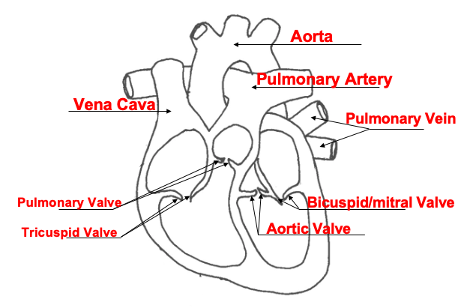

**End of Test**

**M.C.: ___________/30**

**S.A.: ____________/54**

**TOTAL: ______________/84**